IoT Based Home Automation with Smart Fan and AC using NodeMCU

Raj Desai1, Abhishek Gandhi1, Preeti Kathiria2, Smita Agrawal2, and Parita Oza2

1 Student, 2 Assistant Professor CE Department,

Institute of Technology, Nirma University, Ahmedabad.

{16mca012, 16mca015, preeti.kathiria , smita.agrawal, parita.oza}@nirmauni.ac.in

**Abstract.** In today's world of the 21st century, the Internet of things (IoT) has emerged exponentially. Many applications are developed in these fields of automation. When it comes to home automation this concept can be integrated to make it smarter. It makes it easier to access and monitor different home appliances. This paper shows how IoT can be used for smart home automation using NodeMCU and Android Mobile application. The main focus of the paper is, how the sensor nodes collect the data and pass it to the mobile devices to perform some action as per the user's commands and provide support to IoT based mutual controlling between fan and AC based on threshold temperature value.

**Keywords:** Internet of Things (IoT), Home Automation, NodeMCU, Arduino Uno, Android, smart fan and AC

1 Introduction

In this fast working world where the people are busy, it is difficult to manage and control home appliances manually. This work reduces their time and works as they can control the home by a single click on their smart devices [9]. It is like a blessing for elderly and disabled persons also. It gives remote access to the member of the house by which they can control the appliances. As Energy is a very crucial factor in life, Energy cost is saved by using smart sensors like motion sensor detects the motion in the house and it works accordingly with intelligence.

Internet of Things (IoT) has grown rapidly in the last decade, many industries have adopted IoT as their major services. IoT deals with intelligent objects which are connected with sensors and collect data and can communicate with surrounding people using different communication technologies. The goal of IoT is to control and manage objects around us in the more intelligent and useful manner [1] which improves the lifestyle of the humans by providing security, safety, and entertainment as a result of cost-effective living.

Statista has stepped into Market Analytics to build bridges between different sources, methodologies and survey periods and delivers consistent data points to the most relevant topics [10]. In Figure-1 Statista provides revenue generated through the Smart Home market and expected to generate until 2021 based on historical data. Experts have estimated that the revenue of the home automation market will reach $12.81 billion by 2030.

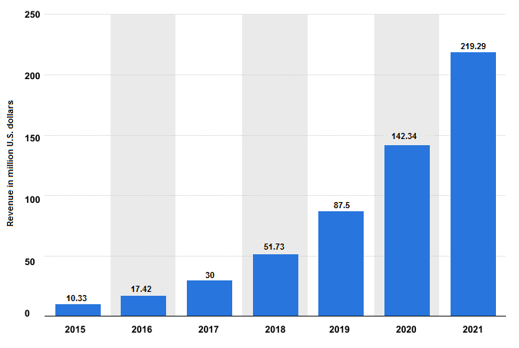

Figure ‑1: Revenue in Smart Home Market [10]

Home Automation System can be developed using a single controller which has the ability to instruct and control various appliances such as lights, fans, AC[11], power plugs, sensors and security systems [2]. The greatest advantage of home automation is that through smart devices like smartphone, laptop, PC's or tablets [3] it managed and controlled various home appliances. Home automation system uses various wireless technologies[22] such as Bluetooth [4], ZigBee [5-6], Wi-Fi [7], GSM [8] to communicate with microcontrollers. There are many IoT based home appliances in which all the appliances can be controlled from their smart devices anywhere at any time as represented in Figure 2. Here, the proposed IoT based home automation system with integration of devices like the smart fan and AC (i.e. mutual controlling between fan and AC) for maintaining room temperature which leads to saving power consumption.

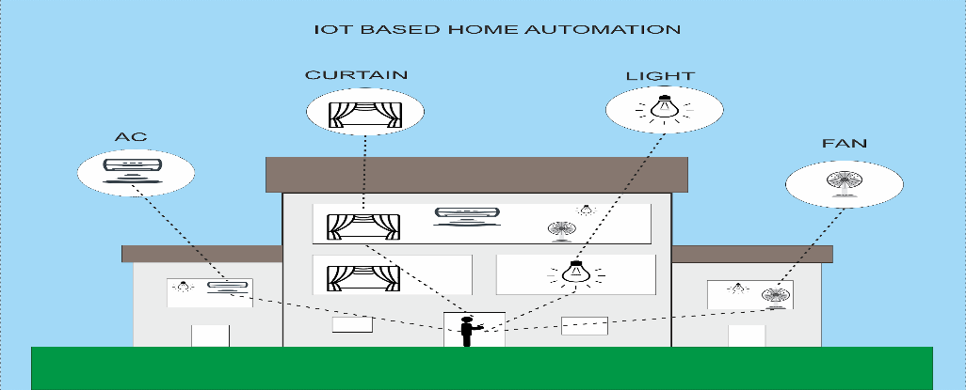

Figure ‑2: Concept of IoT based home automation

The rest of this paper is organized as follows. Section-2 Related work. Section-3 Proposed model and its Implementation. Section-4 challenges and research opportunity. Lastly, Section - 5 concludes the paper.

2 Related Work

For home automation, appliances need to connect with sensor nodes and internet using microcontroller or microprocessor which operates through smart devices based application. Momataz Soliman et al. [5] have been designed IoT enabled smart home using Arduino, where implementation is done using ZigBee Technology in which their proposed model coordinate all devices like AC, Light, and FAN with Arduino UNO Separately. So, that one by one operate all appliances (actuator) but devices did not communicate with each other. Sudhir Yadav et al. [18] have been proposed an IoT based smart home security system in which model uses different types of sensors like PIR sensor, Gas sensor, RFID, Ultrasonic sensor, Fingerprint Sensor, Water flow sensor and so on for measuring required data and based on event occurrence, the system gives appropriate alert to the user via email or SMS. S. Tanwar et al. [13] have been proposed IoT based Home Monitoring and alert System in which Web camera 2.0, PIR Sensor is used and Raspberry Pie is used as a microcontroller which can control the whole system. In this, home monitoring and an alert system can work on the coordination of web camera and PIR sensor and based on detection, the system sent alert to the owner via email and also send captured photos. Kumar Mandula et al. [4] have been proposed an IoT based smart home automation system, which controls appliances based on given command using android application and appropriate action should be taken via Arduino Uno and communication performs using Bluetooth and Wi-Fi both.

Above all systems, focused on home monitoring system or home automation system for controlling various home appliances. The proposed system does the integration of Light with PIR and LDR sensor and novel approach for IoT based mutual controlling between fan and AC based on threshold temperature value for smart fan and AC.

To in line with the proposed model, the comprehensive study of microcontrollers- NodeMCU and Arduino Uno[12] is provided here. NodeMCU is an open source IoT platform. The term NODEMCU refers to the firmware rather than the development kit. It includes Esp8266 Wi-Fi Socket and hardware which is based on the ESP 12 module. It uses the Lua scripting language. It also uses open source projects like Lua-cjson, spiffs, etc. It uses Esp8266-12E as Wi-Fi module, similar to Esp8266 12 which has extra 6 GPIO's. NodeMCU uses the micro USB port for power, programming as well as debugging which has 2x 2.54mm 15-pin header with access to GPIO's, SPI, UART, ADC, and power pins. It also has reset and flash buttons. Power need to NodeMCU is 5V via micro USB port. Dimensions of NodeMCU is 49x 24.5 x13mm.

The Arduino Uno is a microcontroller board based on the ATmega328p. It has 6 Analog

inputs, 14 digital input/output pins, a 16 MHz ceramic resonator, a power jack, a USB

connection, a reset button, and an ICSP header. Power it with an AC-to-DC adapter or

connect it to a computer with a USB cable to get it started. It has SRAM of 2kb EEPROM of 1kb. Arduino can be powered through USB or by an external power supply. The output power is of two types 5V and 3.3V. Arduino provides serial communication which is available on digital pins 0(Rx) and 1(Tx). Dimensions of Arduino are 2.7 in x 2.1 in [68.6mm x 53.3mm]. It is not directly connected with Wi-Fi instead of external communication chips like Esp8266 for Wi-Fi module have to be used.

For better understanding, the comparison between Arduino Uno and NodeMCU based on different parameters is provided in Table -1. Based on given comparative study and consideration of speed, storage and other working aspects in the proposed model, NodeMCU is used for Interfacing with sensor nodes and smart devices with a Wi-Fi module. System memory and clock speed of esp8266 is more than Arduino as well as flash memory that is also greater than Arduino of esp8266.

Table 1 : Comparison Arduino Uno and NodeMCU

|  |  |  |
| --- | --- | --- |
| **Parameters** | **Arduino Uno** | **NodeMCU** |
| Processor | ATMega328p | - |
| System Memory | 2kb | <45kb |
| Clock Speed | 16MHz | 26MHz-52MHz |
| Input Voltage | 7-12V | 5V |
| Operating Voltage | 5V | 3.3V |
| Flash Memory | 32kb | Up to 128MB |
| Communication Supported | IEEE 802.11 b/g/n IEEE 802.15.4 433RF BLE 4.0 via Shield | IEEE 802.11 b/g/n |
| Development Environments | Arduino IDE | Arduino Ide, Lua Loader |
| Programming Languages | C, C++ | C, C++, Lua |
| I/O Connectivity | SPI, I2C, UART, GPIO | UART, GPIO |

3 Proposed System and Implementation

The proposed system consists of different components which are used based on different needs. These components can be classified based on the functionality of the component. Table 2 comprises of different categories of components based on Sensor/Hardware Name, Image of the component, its mechanism, and purpose to use.

Table 2: Different sensors and Hardware specification

|  |  |  |  |
| --- | --- | --- | --- |
| **Sensor /Hardware Name** | **Image of Sensor /Hardware** | **Mechanism** | **Major Use** |
| DTH 11 Temperature Sensor |  | Humidity Measurement | Digital temperature and humidity sensor. |
| PIR Sensor |  | Passive infrared | Motion Detection, Living moving object Detection. |
| LDR Sensor |  | Light Detector | The resistance that changes with the light intensity that falls upon it. |
| IR Transmitter | C:\Users\Raj\Downloads\download.jpg | Receive Infrared signal | In receives, infrared signals received from the remote control. |
| Stepper Motor |  | Converts digital pulses into mechanical shaft rotation | Speed control |
| Esp8266 12e | Image result for esp8266 | Internet connectivity  and micro controlling | It connects microcontroller with internet through Wi-Fi and also used as a controller. |

The proposed system's layered architecture provides the appropriate solution in such a way that in future if one component of any layer is replaced or added, then no need to upgrade the whole system[18]. For example, right now data transmission in layer-2 is possible through Wi-Fi module, if required it can be replaced or added with Bluetooth module then updation is required in that respective layer only.

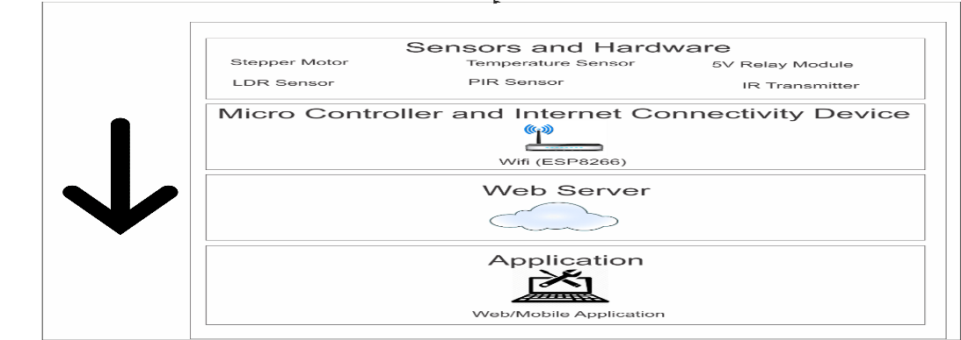

Figure ‑3: Layered architecture of the proposed system

Figure-3 graphically represents the layered architecture of the proposed system and provides information related to component(s) exist in each layer for better understanding. For proposed layered architecture, the working of each layer is discussed herewith:

**Layer 1:** External hardware and sensors: According to the change in the environment, Sensors handover data to the microcontroller.

**Layer 2:** Microcontroller and Internet: Data provided by sensors is analyzed and then actions are taken according to it. The device by which data is transferred from microcontroller to a web server.

**Layer 3:** Web server: Command that is given by the user is transferred to the microcontroller using the web server.

**Layer 4:** Application: Actual user interface for the user interaction to execute commands.

**Proposed System Implementation**

The proposed system implemented for android based smart devices developed in Android Studio. When the application starts, the starting activity displays multiple buttons to the user for controlling different appliances. When the user selects any button, an appropriate command is passed to the web server, web server formulates appropriate JSON object corresponding to the command given by the user, which then passes the JSON object to Esp8266. Esp8266 than parses the JSON object and gives the data to NodeMCU which then performs suitable actions on to the appliances. The overall architecture of the proposed approach with the functions of all modules shown in Figure 4

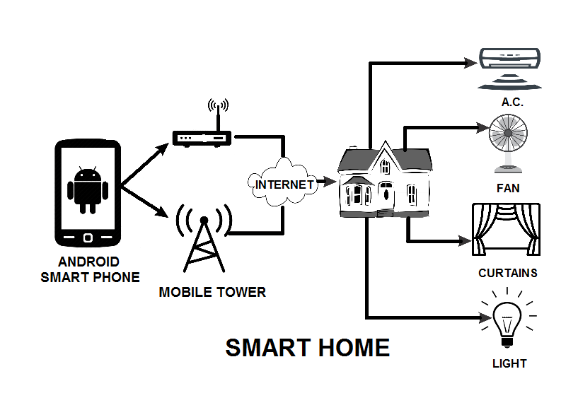

Figure 4: System Architecture of the proposed system

For understanding the interaction between different component (i.e. objects/nodes) state diagrams are represented in Figure-5. The state diagram generally provides the abstract description of the behavior of the system. In Figure-5, it shows the changes in the state as per the given command. Initially, the command is given to the server which in turn passes to the NodeMCU. Different sensors are used for the smart working of appliances like PIR sensor is used to detect motion, DHT11 sensor is for humidity and temperature information and so on.

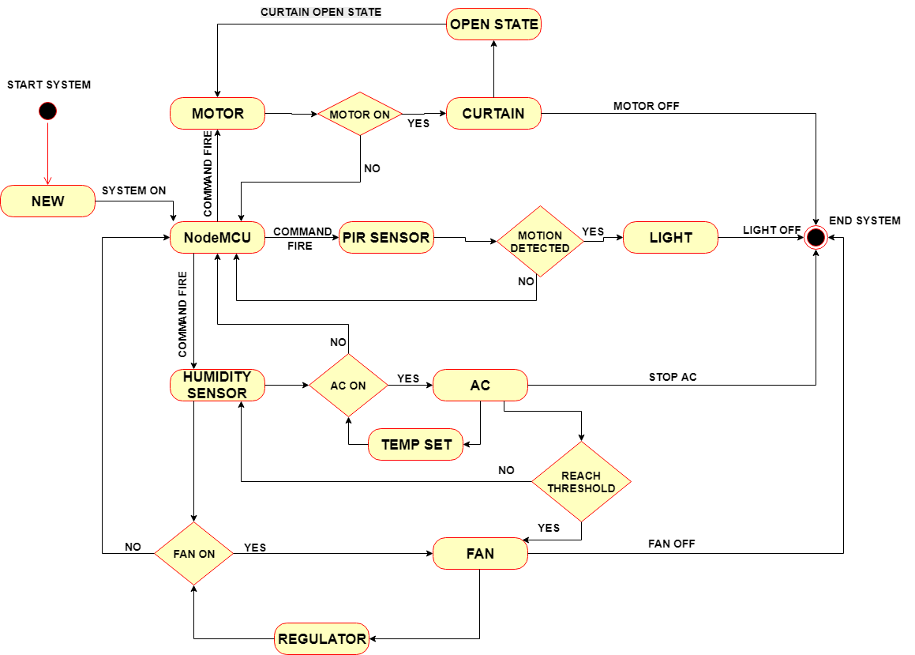

Figure 5: State diagram of the proposed system

Complete working Android application module of the proposed system is shown in Figure 6 (a) and (b). Complete working hardware module of the proposed system is shown in Figure 6 (c) and (d).

|  |  |  |
| --- | --- | --- |
| https://lh4.googleusercontent.com/qMRaQMToyb7L4AwwV0ArFOUzFZ1kJjhVSZMxKsWta1og4JfgX8PrxqCWgNZF3wNeCbTM4BQbMQT1z_n6Pm_5nNwPaofGzW_XHozMzMphQSQMcjJqx92PjmqRCcTlsTGGQdPN1HYzGI1XxOD-fg  Figure – 6 (a) working module in an android device | C:\Users\Raj\Downloads\Screenshot_20180502-121310 (1).png  Figure – 6 (b) working module in an android device | C:\Users\Raj\Downloads\IMG_0057.jpg  Figure – 6 (c) working hardware module |
| C:\Users\Raj\Downloads\image_breadboard_connection.JPG  Figure – 6 (d) working hardware module |

Figure 6 (a) and (b) provides an android application which communicate with hardware module as shown in Figure 6 (c) and (d) respectively. Here, all the sensors are connected to NodeMCU and the appliances are managed through it. The real-time sensor data are passed onto NodeMCU. The data is then passed to the server where it is stored in JSON Object it is then accessed from Mobile. When the respective event occurred from mobile the required command is passed as a JSON object to NodeMCU and afterward, it parsed to activate the appropriate pin(s).

4 Challenges and Research opportunities

One of the primary challenges is to integrate the sensors and applications with embedded devices. Another main challenge is about the security and privacy for connected devices. As the deployed sensors give a large amount of data proper data handling, storing and security is the main concern.

**4.1 Big Data**

A large number of data is being collected from sensors. It comes in the form of 3V that is Variety, Velocity, and Volume. This data cannot be simply stored or processed in Central RDBMS system for that NoSQL database also be used[20][23]. IoT Big Data analytics [19] can be used to find unseen patterns, trends, examine and reveal new information. [14]

**4.2 Distributed Computing**

To deal with the big data distributed approach is more efficient than the centralized data storage system. Rather than computing on cloud servers computing chips are installed with sensors for Computing. [15]

**4.3 Privacy and Security**

No specific architecture is there for IoT, there are different layers in it and attacks can be done on any of them such as Denial of Service attack, unauthorized access of tags, code injection or tag cloning. [16]

**4.4 Edge Computing**

Storage and Computing data on to cloud nowadays is a too lengthy process, instead, Edge computing can be used by which local client machines can be effectively utilized and can provide timely and intelligent services.[17][21]

5 Conclusion

In this paper, the prototype of IoT based home automation system is presented. It is shown that different appliances can be controlled through the task already defined. By connecting the web services and sensors, appliances controlling will become easier and more human-friendly. This paper also presents the proposed model for smart home automation using IOT integration with web services, different sensors, and microcontroller. The user can remotely control the home appliances through an android phone. The result of the proposed system has met our expectations, the sensors and the app work on real-time scenarios. The proposed IoT based home automation system with integration of devices like a smart fan and AC (i.e. mutual controlling between fan and AC) for maintaining room temperature which leads to saving power consumption. It may be concluded that the proposed system will be friendly and useful to all the generations as well as for easy controlling of home appliances. This paper also confirms the advantage of NodeMCU over Arduino in terms of cost, connectivity, and many more parameters.

References

1. https://en.wikipedia.org/wiki/Internet\_of\_things/
2. Felix, Carelin, and I. Jacob Raglend. "Home automation using GSM." Signal Processing, Communication, Computing and Networking Technologies (ICSCCN), 2011 International Conference on. IEEE, 2011.
3. Al-Ali, Abdul-Rahman, and Mohammad Al-Rousan. "Java-based home automation system." IEEE Transactions on Consumer Electronics 50.2 (2004): 498-504.
4. Mandula, Kumar, et al. "Mobile-based home automation using the Internet of Things (IoT)." Control, Instrumentation, Communication and Computational Technologies (ICCICCT), 2015 International Conference on. IEEE, 2015.
5. Gill, Khusvinder, et al. "A zigbee-based home automation system." IEEE Transactions on Consumer Electronics 55.2 (2009).
6. Han, Dae-Man, and Jae-Hyun Lim. "Design and implementation of smart home energy management systems based on zigbee." IEEE Transactions on Consumer Electronics 56.3 (2010).
7. Soliman, Moataz, et al. "Smart home: Integrating the internet of things with web services and cloud computing." Cloud Computing Technology and Science (CloudCom), 2013 IEEE 5th International Conference on. Vol. 2. IEEE, 2013.
8. Wang, Ming, et al. "An IoT-based appliance control system for smart homes." Intelligent Control and Information Processing (ICICIP), 2013 Fourth International Conference on. IEEE, 2013.
9. Baviskar, Jaypal, et al. "Real-time monitoring and control system for the greenhouse based on 802.15. 4 wireless sensor network." Communication Systems and Network Technologies (CSNT), 2014 Fourth International Conference on. IEEE, 2014.
10. https://www.statista.com/statistics/644418/smart-home-automation-revenue-in-india/
11. Kathiria, P., Vadgama, B., Shah, D., Ashishdeep, A., & Agrawal, S. (2017). IoT Based approach for Controlling Electrical Peripheral Devices of Auditorium. *International Journal of Advanced Research in Computer Science*, *8*(5).
12. https://www.arduino.cc/
13. Tanwar, S., Patel, P., Patel, K., Tyagi, S., Kumar, N., & Obaidat, M. S. (2017, July). An advanced Internet of Thing based security alert system for the smart home. In *2017 International Conference on Computer, Information and Telecommunication Systems (CITS)* (pp. 25-29). IEEE.
14. https://www.whizlabs.com/blog/iot-and-big-data/
15. Chien, S. Y., Chan, W. K., Tseng, Y. H., Lee, C. H., Somayazulu, V. S., & Chen, Y. K. (2015, January). Distributed computing in IoT: System-on-a-chip for smart cameras as an example. *The 20th Asia and South Pacific Design Automation Conference*(pp. 130-135). IEEE.
16. Ren, Z., Liu, X., Ye, R., & Zhang, T. (2017, July). Security and privacy on the internet of things. In *2017 7th IEEE International Conference on Electronics Information and Emergency Communication (ICEIEC)* (pp. 140-144). IEEE.
17. Ren, J., Pan, Y., Goscinski, A., & Beyah, R. A. (2018). Edge computing for the internet of things. *IEEE Network*, *32*(1), 6-7.
18. Yadav, Sudhir, Jaiprakash Verma, and Smita Agrawal. "SUTRON: IoT-based Industrial/Home Security and Automation System to Compete the Smarter World." International Journal of Applied Research on Information Technology and Computing 8.2 (2017): 193-198.
19. Verma, Jai Prakash, et al. "Big data analytics: Challenges and applications for text, audio, video, and social media data." International Journal on Soft Computing, Artificial Intelligence and Applications (IJSCAI) 5.1 (2016).
20. Agrawal, S., Verma, J. P., Mahidhariya, B., Patel, N., & Patel, A. (2015). Survey on Mongodb: An Open-Source Document Database. Database, 1(2), 4.
21. Tanwar, S., Kumari, A., Tyagi, S., & Kumar, N. (2018). Verification and Validation Techniques for Streaming Big Data Analytics in the Internet of things Environment. *IET Networks*.
22. Oza, P., & Sharma, P. (1800). Optimized Data Aggregation Protocol in WSN for Automation of water Sprinklers. *Energy*, *1400*, 1600.
23. Agrawal, S., & Patel, A. (2016). AStudy ON GRAPH STORAGE DATABASE OF NOSQL. *International Journal on Soft Computing, Artificial Intelligence, and Applications (IJSCAI)*, *5*(1).